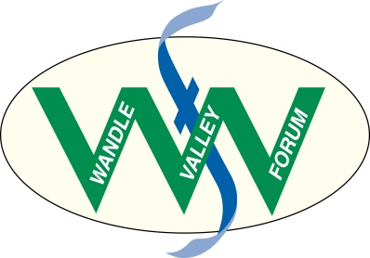
WANDLE FORTNIGHT 10th September – 25th September 2016
Application for grant

Wandle Fortnight is a celebration of the Wandle run by the community for the community. Dozens of community-led events and activities are being planned by local groups and voluntary organisations. Wandle Valley Forum is delighted to be offering small grants of between £20 and £200 to support groups who want to get involved.

To apply for funding please complete this short application and return it to wandlevalleyforum@gmail.com or Wandle Valley Forum, 43 Bramcote Avenue, Mitcham CR4 4LW by July 16th at the latest. Please read the guidance below before submitting your application.

Your application

What are you planning to do?

When and where are you planning to do it?

Who are you hoping to benefit?

How much funding are you requesting? (£20 - £200)

What will you spend the money on?

Your details

Your name:

Your group/organisation:

Contact address:

Telephone Number:

E-mail:

Web site:

If successful then how do you want your grant paid?

Cheque – Who is this payable to?

Bank transfer – Please provide bank details

a/c name:

Sort code:

a/c number

Guidance
1. Grants are available for community groups, voluntary organisations and not-for-profits. Applications by individuals will be considered providing they support community activity.
2. Grant funding is only to be used on events and activities being run for the community within the Wandle Valley Regional Park between 10th September and 25th September 2016 as part of Wandle Fortnight.
3. Grant applications need to be made using this form.
4. Wandle Valley Forum will assess grant applications for eligibility and select those to receive funding. We will endeavour to make decisions by July 31st and our decisions are final.
5. We ask that all recipients acknowledge the source of the funding and we will provide the necessary logos.
6. All successful groups need to provide feedback on how they used the grant and either be or become a Wandle Valley Forum supporter (free). Your contact details will be shared with Living Wandle Landscape Partnership.

We are grateful to Living Wandle Landscape Partnership and Heritage Lottery Fund for the support that makes this programme possible
