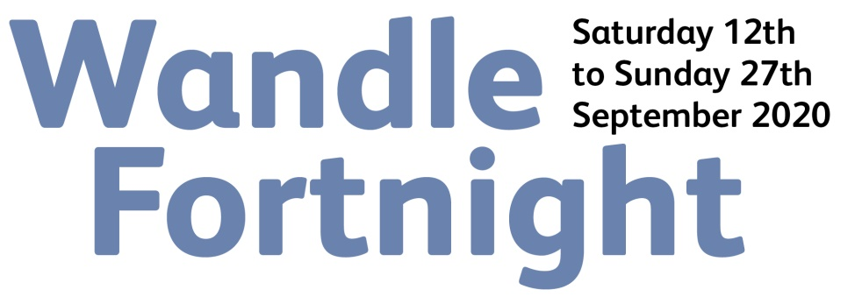
GRANT APPLICATION
Wandle Fortnight is a celebration of the Wandle run by the community for the community. Dozens of community-led events and activities are being planned by local groups and voluntary organisations. Wandle Valley Forum is delighted to be offering small grants of between £50 and £200 to support groups who want to get involved. This can be used on existing or new events and activities.

To apply for funding please complete this short application and return it to wandlevalleyforum@gmail.com or Wandle Valley Forum, 43 Bramcote Avenue, Mitcham CR4 4LW by August 23rd at the latest. Please read the guidance below before submitting your application. We will be making decisions on these grants as soon as we can and intend to be able to make awards shortly before Wandle Fortnight begins.

You are asked to complete a separate registration form to have your event or activity included in Wandle Fortnight.

Your application

What are you planning to do?

When and where are you planning to do it?

Who are you hoping to benefit?

How much funding are you requesting? (£50 - £200)

What will you spend the money on?

What consideration have you given to making your event or activity Covid-19 secure??

Your details

Your name:

Your group/organisation:

Contact address:

Telephone Number:

E-mail:

Web site:

If successful then how do you want your grant paid?

Cheque – Who is this payable to?

Bank transfer – Please provide bank details

a/c name:
Sort code:
a/c number:

Guidance
1. Grants are available for community groups, voluntary organisations and not-for-profits. Applications by individuals will be considered providing they support community activity.
2. Grant funding is only to be used on events and activities being run for the community within the Wandle Valley Regional Park (boundary line in red on map) between 12th September and 27th September 2020 as part of Wandle Fortnight. It is available for existing as well as new events and activities. Events should be free.
3. Grant applications need to be made using this form.
4. Wandle Valley Forum will assess grant applications for eligibility and select those to receive funding. We will endeavour to make decisions in time to make awards before Wandle Fortnight begins. Our decisions are final.
5. We ask that all recipients acknowledge Wandle Valley Forum as the source of the funding.
6. All successful groups need to provide feedback on how they used the grant and either be or become a Wandle Valley Forum supporter (free). Your contact details will be used to keep you in touch with the work of Wandle Valley Forum.
7. Applicants are responsible for providing appropriate insurance cover and respecting Covid-19 restrictions during any event or activity
We are grateful to The Collective for the support that makes this programme possible

