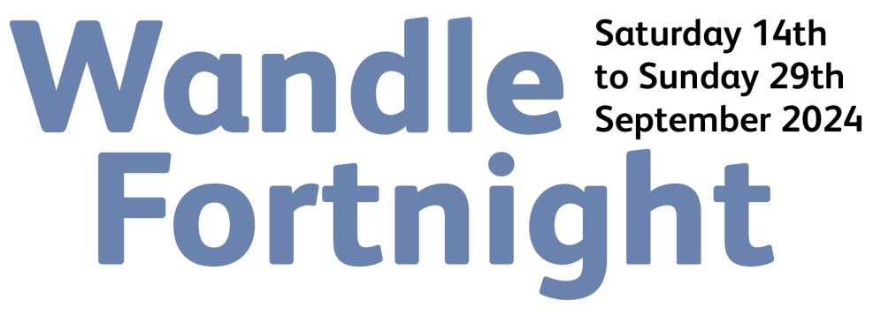

WANDLE GRANT APPLICATION
Wandle Fortnight is a celebration of the Wandle run by the community for the community. Dozens of community-led events and activities are being planned by local groups and voluntary organisations. Wandle Valley Forum is delighted to be offering small grants of between £50 and £200 to support groups who want to get involved. This can be used on existing or new events and activities.

To apply for funding please complete this short application and return it to wandlevalleyforum@gmail.com. You can apply at any time and we will make decisions on a rolling basis. To be sure of receiving a grant for Wandle Fortnight 2024 we must receive your application by August 25th 2024 at the latest. Please read the guidance below before submitting your application.

You are asked to complete a separate registration form (available on our website) to have your event or activity included in Wandle Fortnight. This is required of all public events and activities benefiting from a Wandle Grant.

Your application

What are you planning to do?

When and where are you planning to do it?

Who are you hoping to benefit?

How much funding are you requesting? (£50 - £200)

What will you spend the money on?

Your details

Your name:

Your group/organisation:

Contact address:

Telephone Number:

E-mail:

Web site:

If successful then how do you want your grant paid?

Cheque – Who is this payable to?

Bank transfer – Please provide bank details

a/c name:
Sort code:
a/c number:

Guidance
1. Grants are available for community groups, voluntary organisations and not-for-profits. Applications by individuals will be considered providing they support community activity. Grants are not available to pay for volunteer time.
2. Grant funding is only to be used on events and activities being run for the community within the Wandle Valley Regional Park (boundary line in red on map). Applications may be made at any time but the event or activity must include something happening between 14th September and 29th September 2024 as part of Wandle Fortnight and/or as part of a future Wandle Fortnights. It is available for existing as well as new events and activities. Events should be free.
3. Grant applications need to be made using this form. Details of events or activities must also be provided using the Wandle Fortnight event registration form.
4. Wandle Valley Forum will assess grant applications for eligibility and select those to receive funding. We will make decisions on a rolling basis. Our decisions are final. We are not responsible for any costs you incur in anticipation of a grant.
5. We ask that all recipients acknowledge Wandle Valley Forum as the source of the funding.
6. All successful groups need to provide feedback on how they used the grant and either be or become a Wandle Valley Forum supporter (free). Your contact details will be used to keep you in touch with the work of Wandle Valley Forum.
7. Applicants are responsible for providing appropriate insurance cover.

